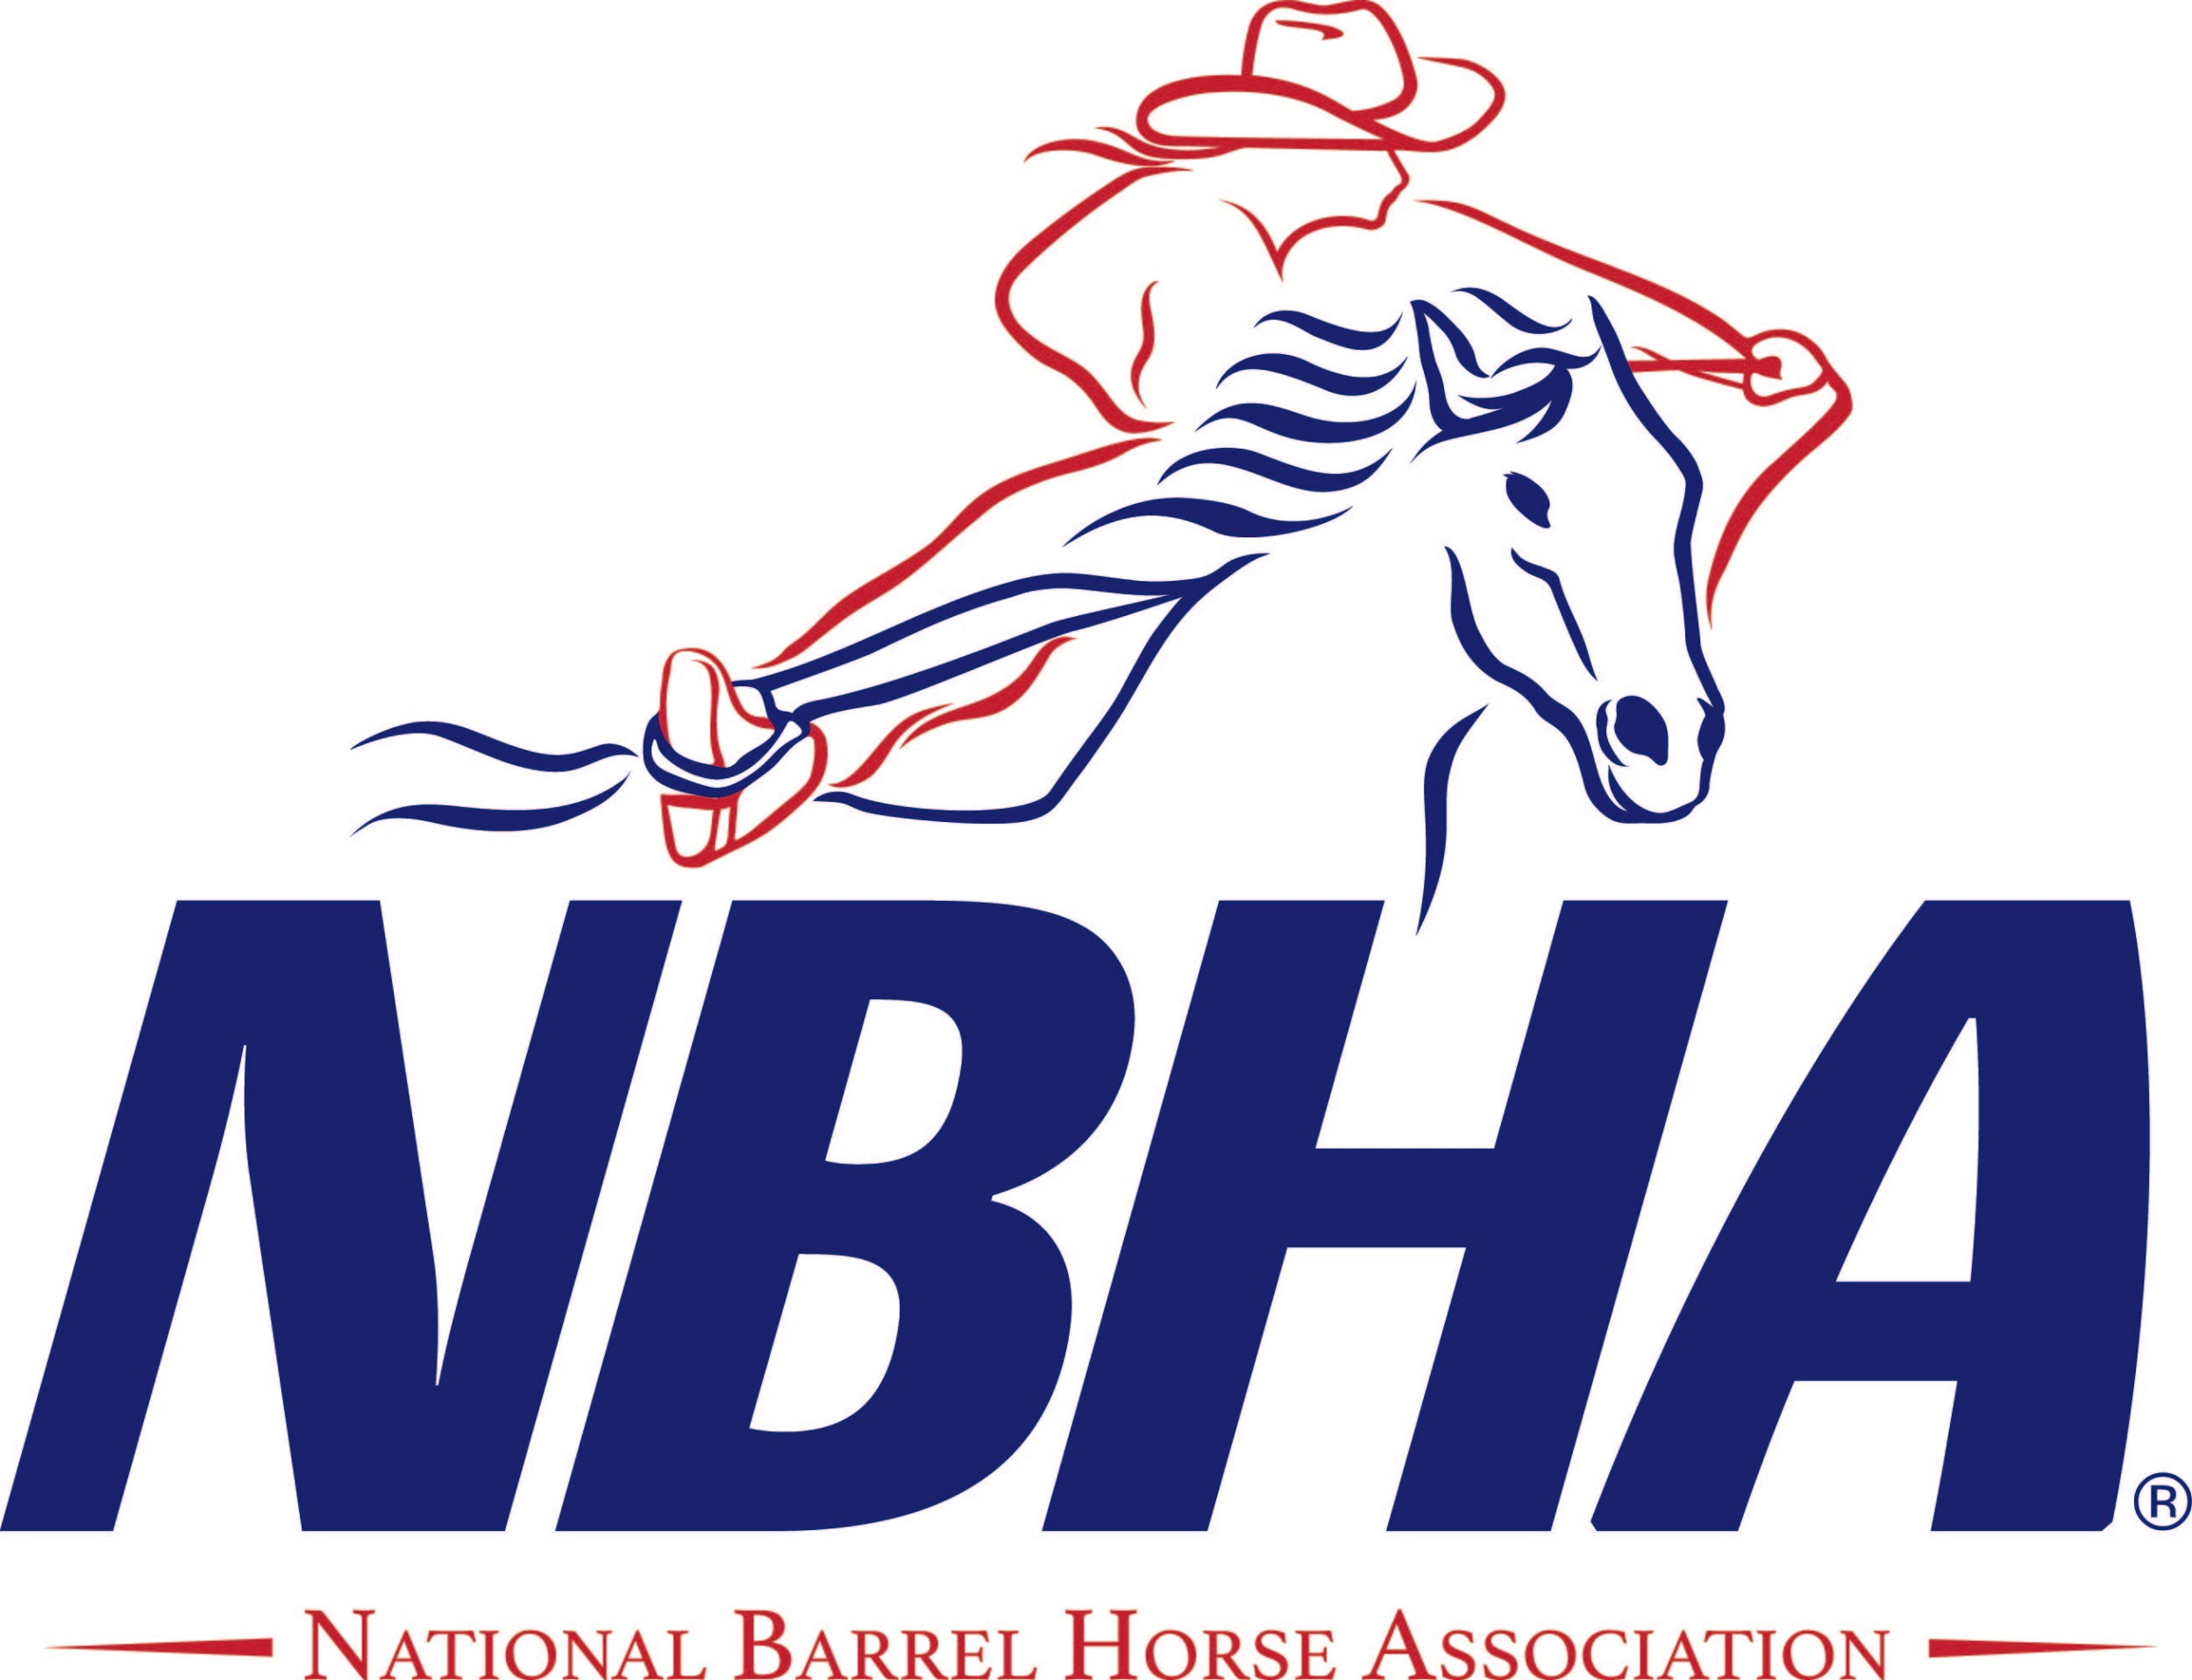

June 19th, 20th & 21st 2026
CUSTER COUNTY FAIRGROUNDS - BROKEN BOW, NE
$5,000.00 ADDED MONEY
BUCKLES/CHAMPIONSHIP CHAIRS & ECT. TO DIVISION CHAMPIONS
AWARDS TO TOP 10 IN AVERAGE IN OPEN/TOP 4 IN SENIOR & YOUTH AVERAGE
RULES FOR THE NEBRASKA NBHA STATE CHAMPIONSHIPS

- Each contestant must check in at the show office.
- Pre-entries must be postmarked by June 5th, 2026 OR on-line entry open till June 14th^{@noon}
- Late entries if you are properly qualified will be taken until June 19th 2026 @ 5:00 PM. 25$ LATE FEE LATE ENTRIES TAKEN ON SITE ONLY!!!!!
- All dogs must be on leashes.
- No GAS POWERED Scooters or 4whlrs will be allowed during the State Championships held at Custer County Fairgrounds. ONLY ELECTRIC POWERED! NOTHING ALLOWED IN ARENA!!!!!
- At least 1 bag of wood shaving is required for each stall. OUTSIDE SHAVINGS ALLOWED!!!!
- NO REFUNDS FOR ANY REASON ONCE THE DRAW IS POSTED - - DO NOT ASK !!!!!!!!
- Draws will be posted to the NE NBHA facebook page and also on site FOR THE Pre-entered contestants!!!! THERE WILL BE A NEW DRAW EACH DAY!! LATE ENTRIES WILL RUN IN THE LATE DRAW EACH DAY!!!!!!
- A maximum of three gate calls will be given after which time a contestant will be disqualified. ALL RIDERS WILL HAVE A MAXIMUM OF 2 MINUTES TO GET THEIR HORSES INTO THE ARENA. ALL HORSES MUST MAINTAIN FORWARD MOTION AS THEY ENTER THE ARENA. A VIOLATION OF THIS WILL RESULT IN A NO TIME!
- Only the next 5 riders will be allowed in the warm-up area. This is for the safety of the both the horses and riders
- If a contestant competes out of turn he/she will be disqualified.
- Two electronic timers will be used for all rides. Should both timers not function, a rerun will be granted immediately after the event is complete for the day and after a drag, or at the Show Managers discretion.
- There will be no reruns given if a horse falls.
- “Zero Tolerance Policy” will be enforced anyplace on grounds!!!
- Knocking over a barrel during competition will result in a no time.
- No signs, banners or posters shall be displayed without prior approval of the Show Manager. ABSOLUTELY NO SELLING OF GOODS IF NOT A SPONSOR OF THIS EVENT OR A PAID VENDOR!!!! THIS CAN AND WILL RESULT IN A DISQUALIFICATION!!!!!
- You may enter as many horses as you want.
- Contestants cannot change horses during an event.
- Open will have two races. The Champions will then be determined by the average of the two runs. Since the average is determined by adding the two times together, the splits must be doubled. (1 second off for 2-D, 2 seconds off for the 3-D, 3 seconds off for the 4D and 4 seconds off for the 5-D). Youth and Senior will be figured for a 4D ½, ½, whole split with the avg. figured accordingly!
- In the event of a tie for Champion in any division, the riders can either run in a runoff or flip a coin.
- Target Shoot Out Champion will be determined by comparing the time run in the 1st race of the Open & Youth to the time run in the 2nd race of the Open & Youth and the contestant with the closest time wins.
- In the event of a tie for Target Shoot-Out Champion, the contestants will flip a coin to decide the winner.
- A horse may only run once per class, except Rule 12, Section A of the NBHA rule book.
- A horse/rider cannot change draw positions under any circumstances.
- Horse substitutions must be made in the show office before first go on Saturday morning.
- The Open will pay out in accordance to the NBHA Rules for a 5D payout as will the Youth and Senior divisions in Accordance to the NBHA Rules for a 4D (1/2,1/2,whole) Payout!!!!
- Payouts and Prizes will be awarded AS THE SCHEDULE OF EVENTS LISTS!!!!!
- In the event there are not enough riders qualify in a division as monies to be paid, the money which is unaccounted for shall be divided equally among those who have placed in that division. If no riders qualify in a division, the prize money for that division shall be equally divided among those riders in the other divisions of that class who have won money.
- Champions will be determined and awarded buckles after Sundays runs. Western attire must be worn for all photos.
- Any questions or disputes that may arise during the show not covered by the rules above, will be settled by the Show Manager whose decision will be FINAL!!!!!
- 75% of entry fee will remain in purse plus 100% of added money. 25% will be deducted for show expenses.
- Return check fee is $40.00.
- NBHA dress code and hat rule will be enforced. Contestants will be fined for loosing their hat at any time in competition arena & alleyway in & out! Fines payable to office they go to barrel setter that got the hat! Show management reserves the right to refuse any entry. COLLARED SHIRT/LONG SLEEVES/BUTTON OR SNAP MUST BE WORN!!
- IN SUBMITTING MY ENTRY, I HEREBY RELEASE THE SHOW ORGANIZER, THE NBHA, AND ANY OFFICIAL, EMPLOYEE, DIRECTOR OR AGENT OF SAME, FROM ANY CLAIM OR RIGHT FOR DAMAGES, WHICH MAY OCCUR TO MY SELF, MY FAMILY MEMBERS, MY HORSE(S) OR MY PERSONAL PROPERTY AT THIS SHOW OR IN TRANSIT.

